Module End 1 Mini Project Observation

Step 1 Find and replaces the values as C into CUST

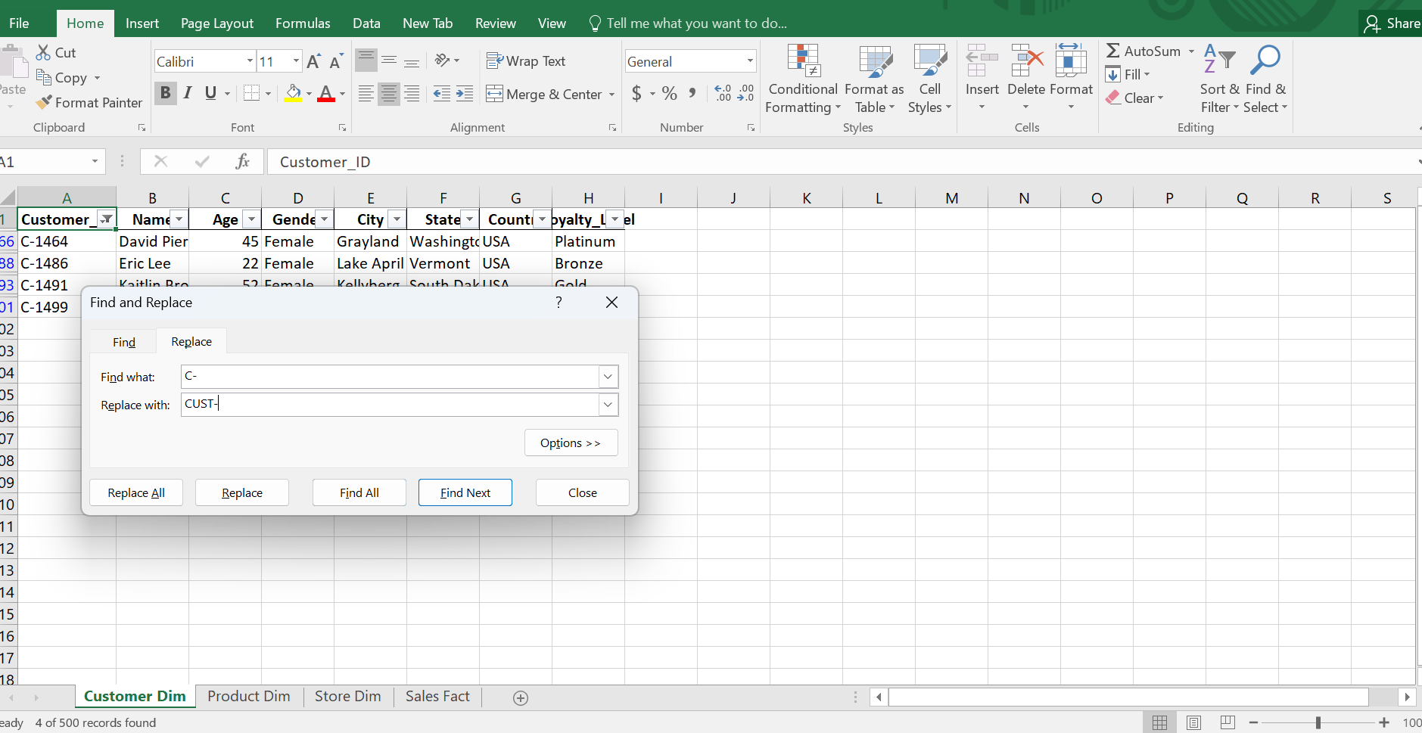

Step 2 Find and replaces the value as United States of America into USA

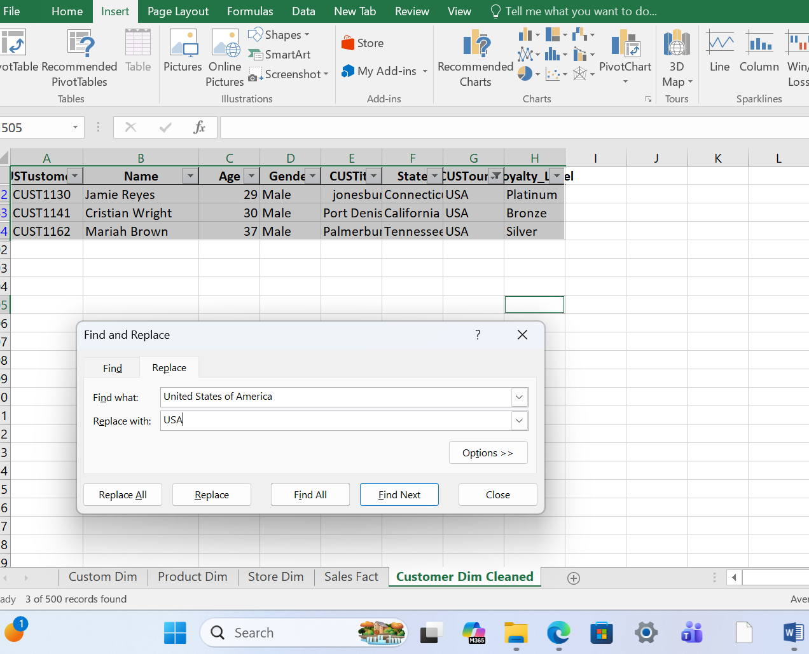

Step 3 There is an missing loyalty value 4 out of 500, 4 will be removed it will not affected Hence removed

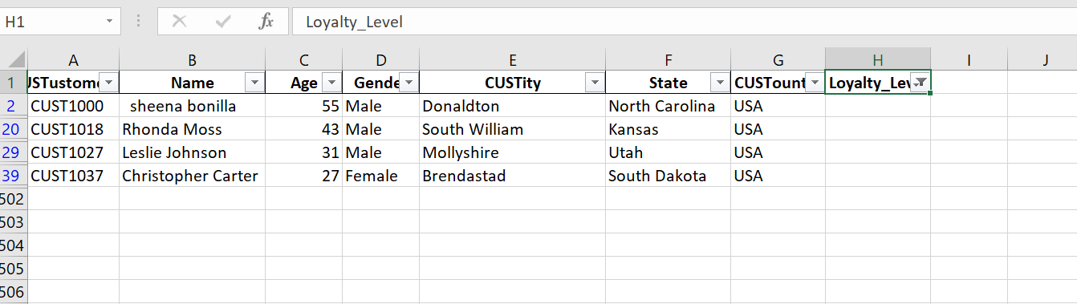

Step 4 Find and replace the values as P- into PROD

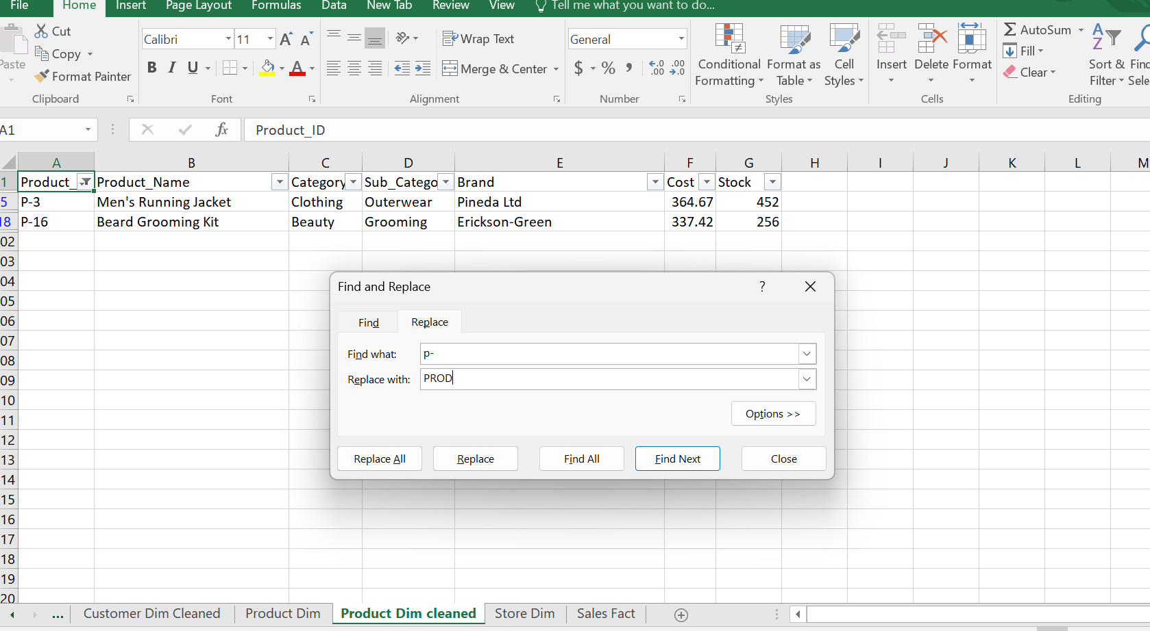

STEP 5 To find the average of cost value with using by average function & Find missing values

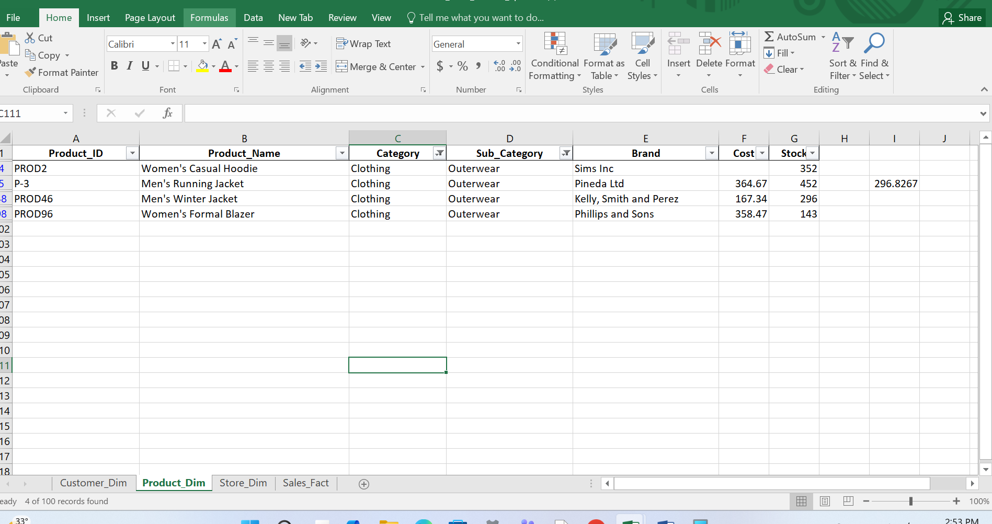
step 6 To find the bottom cost value using average function
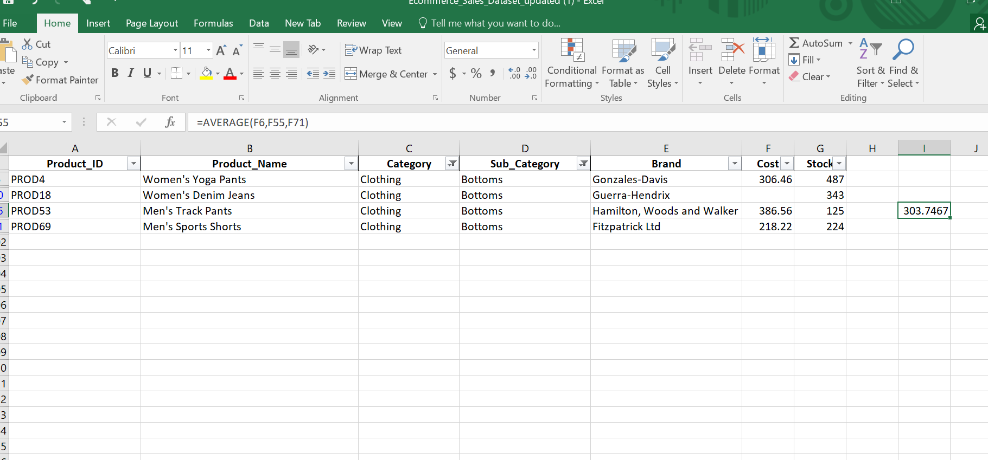

step 7 to find the average of top cost value

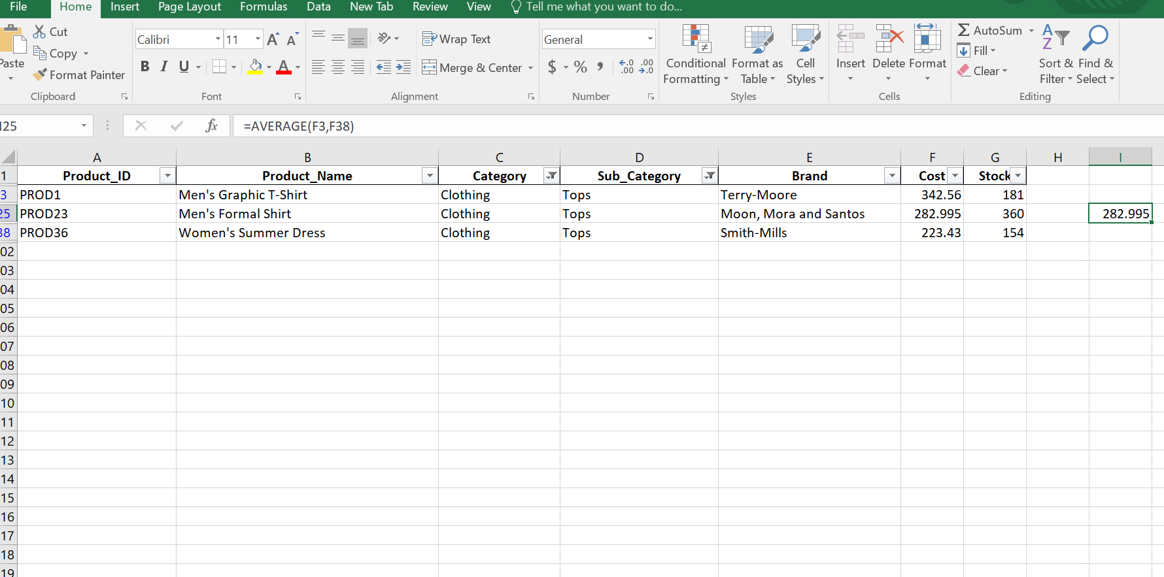

STEP 8 To find the median value of beauty category & find cost value

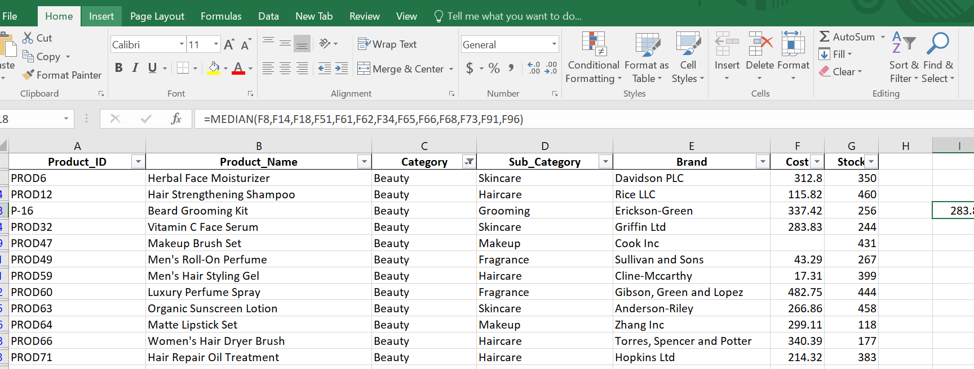

step 9 To find the median value and find cost value of home décor

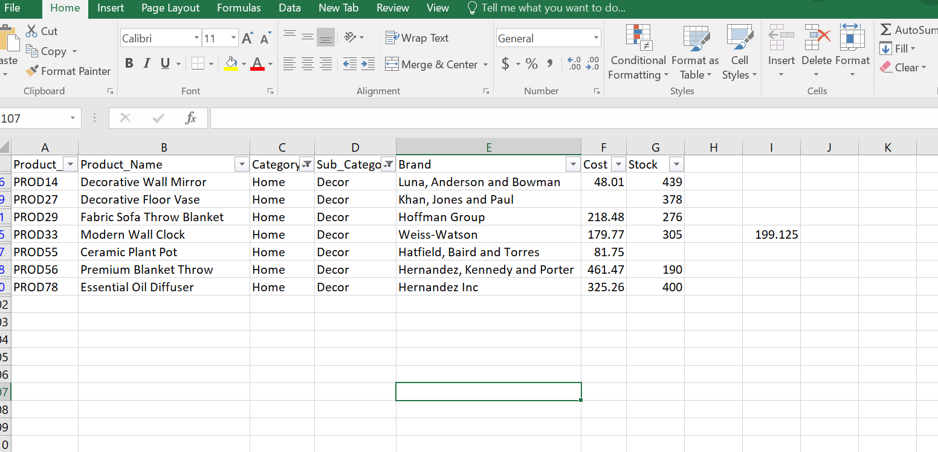

step 10 To find the stock values by using median

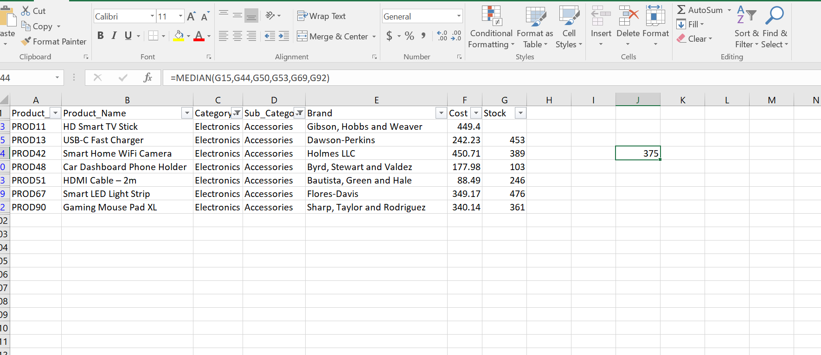

STEP 11 Now product dim was cleaned and missing data cleared

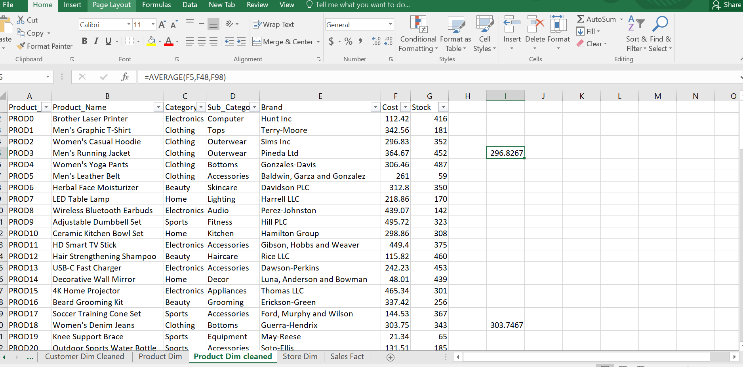

step 12 Finally values will be round off the cost and stock values

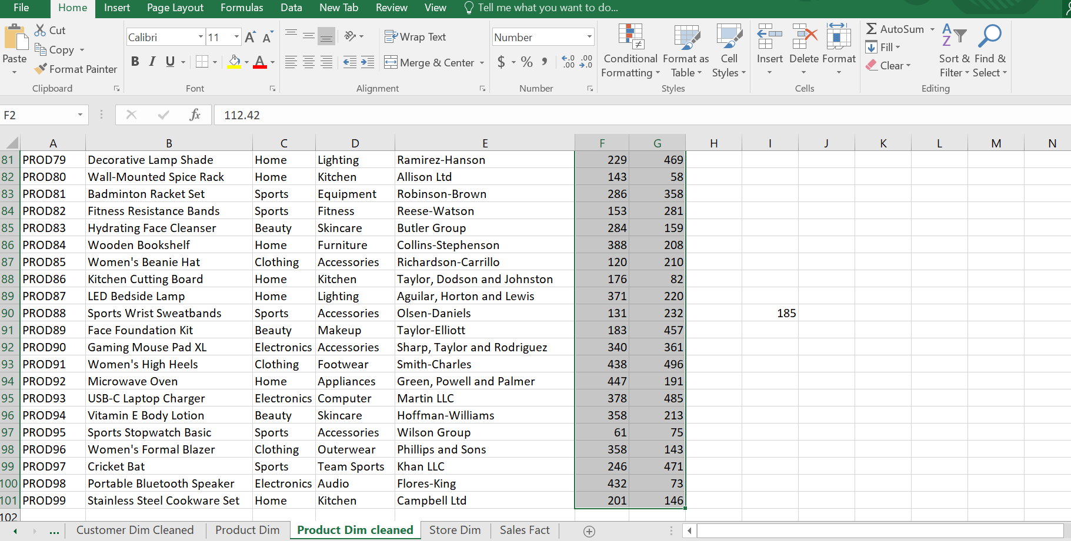

step 13 To find the duplicate store

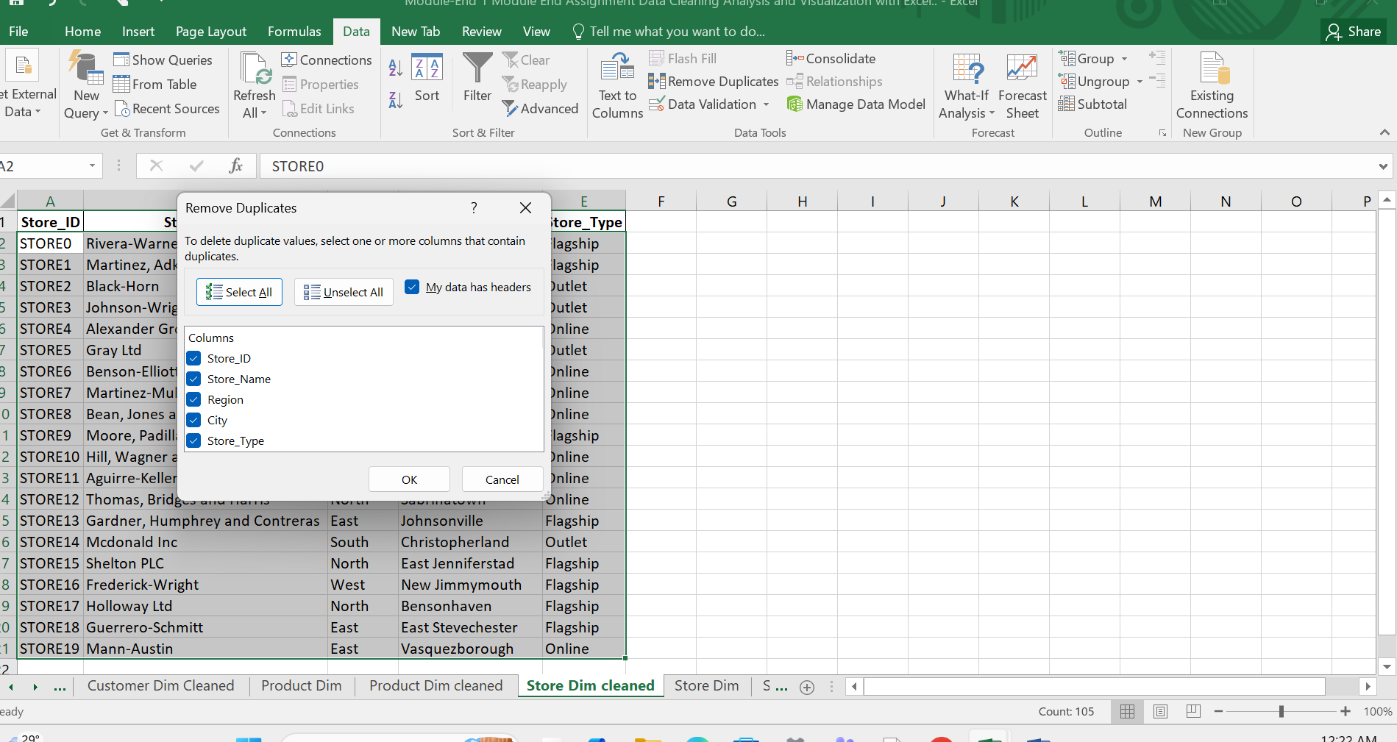

step 14 There is no duplicate store

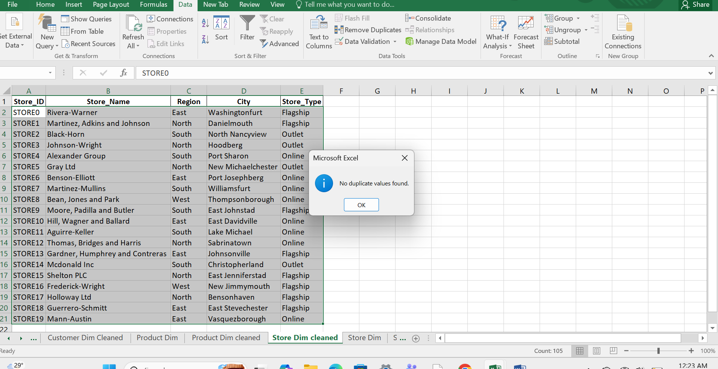

STEP 15 To identified the missing values of quantity by using formulae

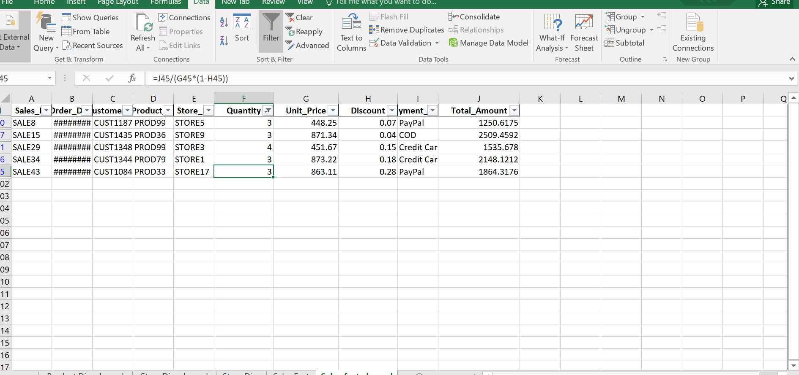

step 16 To find the missing values of discount by using formulae

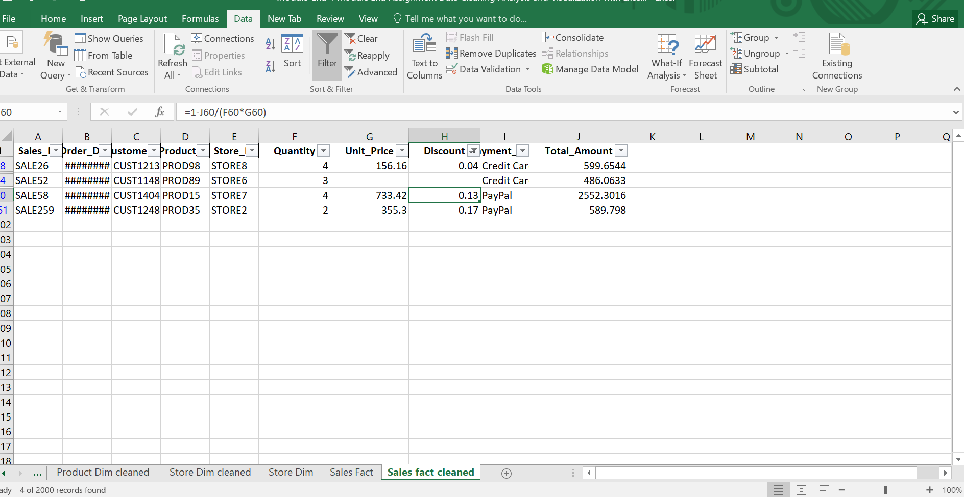

step 17 To find out the unit prices using by formulae

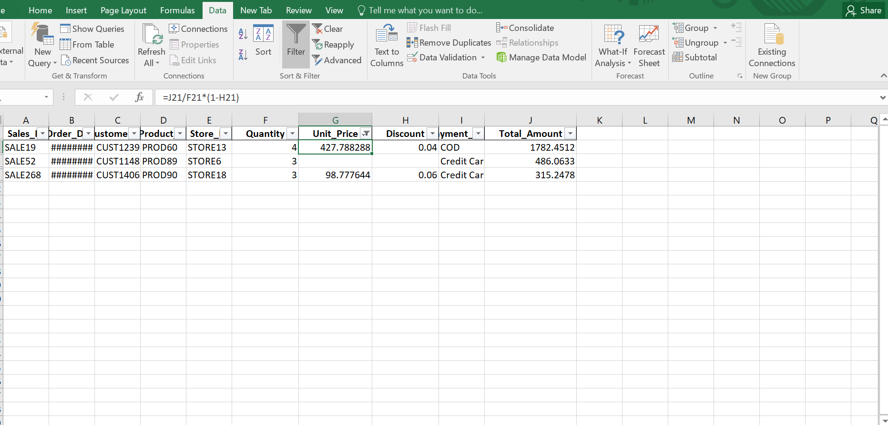

STEP 18 To find the total amount with using by the formulae

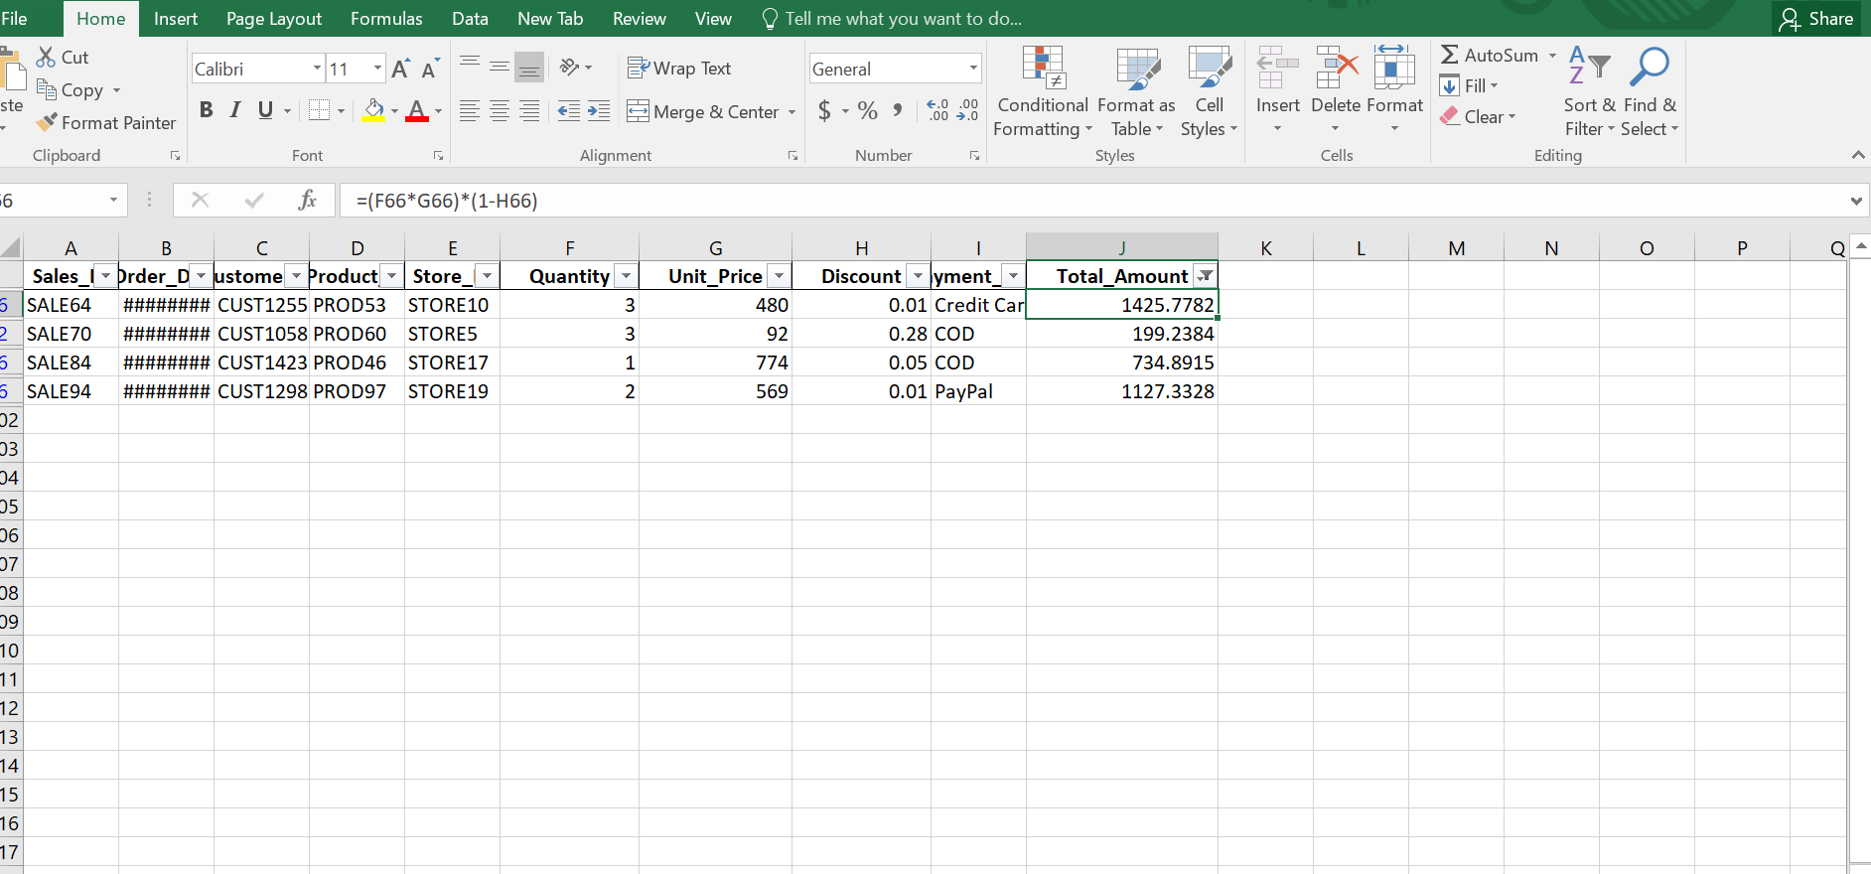

STEP 19 Using analysis Tool Pak for all columns

